 Pegasys
[Credit Card- View Monthly Transactions Reports]

- Monthly CRCD transactions—lists all transactions for a selected credit card statement period by Credit Card Alias and can be utilized by an Approving Official as approval of a cardholder’s credit card purchases that have been logged and reconciled in Pegasys. If a charge has been reconciled in Pegasys, the report also displays all applicable reconciliation information.

Figure 1
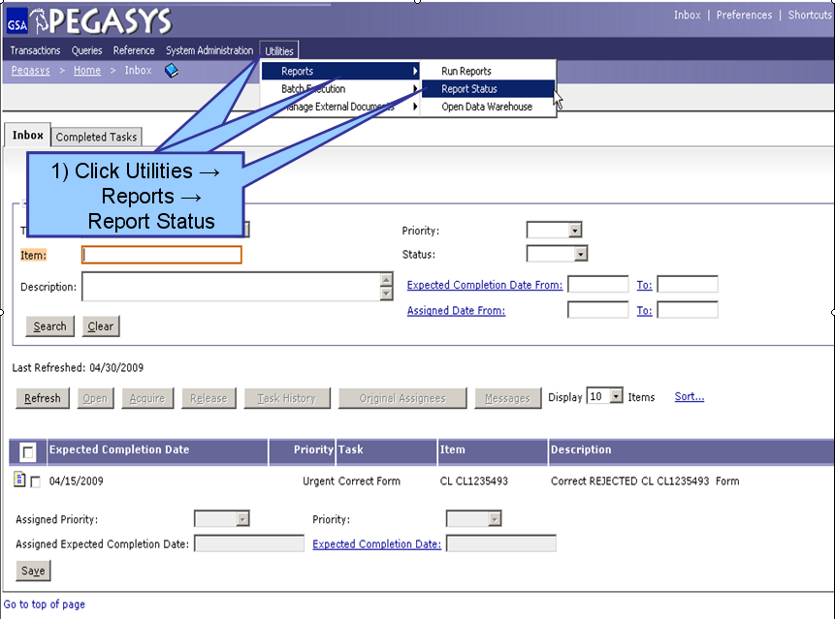
Figure 1

- From the Pegasys homepage, click on Utilities on the Menu Bar
- Click on Reports.
- Click on Report Status.

**Report Status Maintenance is displayed for all processing and/or completed reports**

Figure 2
Figure 2

- To find a report, the user can search by Report Subsystem. Enter all known information. (Step 1)
- Click Search. (Step 2)
- When the results are returned, select a report from the populated field. (Step 3)
- Click Details after the report is selected. (Step 4)
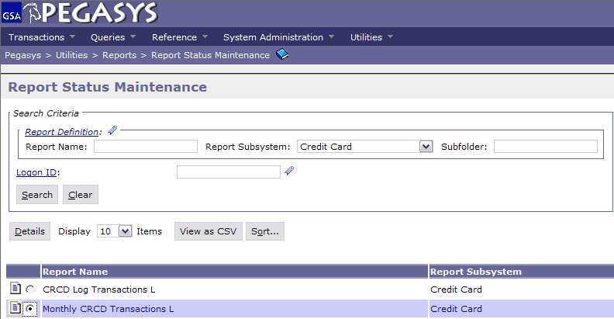
1) Search by:
Subsystem
2) Click Search
3) Select the Report
4) Click Details
(OVER)

Figure 3
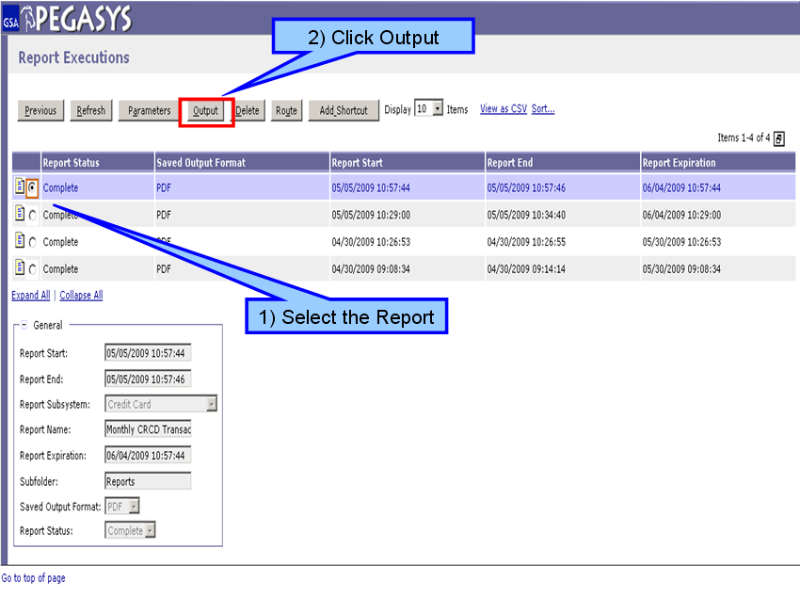
Figure 3

- On the Report Executions page, select the report to be viewed. (Step 1)
- Click Output after the report has been selected to view the report as a PDF file. (Step 2)

